

Matrices del CNC

DISEÑO MECATRONICO



17 de febrero de 2019

ARIAS RAMOS JOSÉ ANTONIO REY.

MORAN GARAVITO CARLOS ENRIQUE.

INGENIERIA MECATRONICA.

UPZMG 8°A T/M

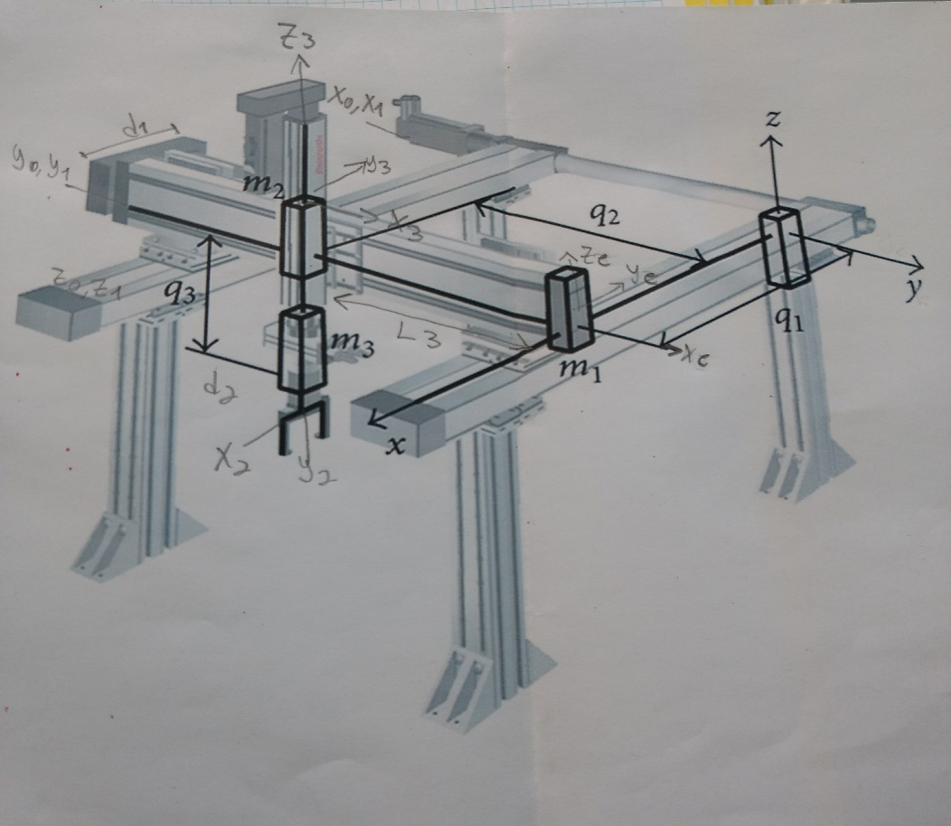

|  |  |  |  |  |
| --- | --- | --- | --- | --- |
| ESLABON | $$a i-1$$ | $$∝i-1$$ | $$d i$$ | $$θ i$$ |
| 1 | 0 | 0 | d1 | 0 |
| 2 | 0 | 90 | d2 | 90 |
| 3 | 0 | 90 | d3 | 90 |
|  |  |  |  |  |

